**SOFTWARE REQUIREMENTS SPECIFICATION**

COLLEGE ONLINE QUIZ SYSTEM



Prepared By-

Snaheel Yadav

(159101141)

**Table of Contents**

**1. Introduction**

1.1 Purpose

1.2 Scope

1.3 References

**2. Overall description**

2.1 Product functions

2.2 User characteristics

2.3 Assumptions and dependencies

**3. Specific requirements**

3.1 Non-functional requirements

3.1.1 User interfaces

3.1.2 Software interfaces

3.2 Functional requirements

3.2.1 Validation to be perform

3.2.2 New user registration by admin

3.2.3 Conduct quiz

3.3 Performance requirements

3.4 Design constraints

**4. Diagrams**

4.1 Use Case Diagram

4.2 Class Diagram

4.3 Sequence Diagram

4.4 Activity Diagram

4.5 Deployment Diagram

4.6 Component Diagram

**5. GUI Screenshots**

**[1] Introduction**

**1.1 Purpose**

This is web application provides facility to conduct online examination in a college. Is saves time as it allows large number of students to give the exam at the same time and display the result just after the exam is finished. The teacher in this online quiz system have the privilege to create, modify and delete the test papers and it’s particular questions.

**1.2 Scope**

This can be used in a lot of educational institutions. It can be used by a large number of student to give their exams any time as it is a web based application.

**1.3 References**

• IEEE Std 830-1998(Revision of IEEE Std 830-1993)

• IEEE Std 828-1998, IEEE Standard for Software Configuration Management Plans.

• IEEE Std 610.12-1990, IEEE Standard Glossary of Software Engineering Terminology.

• R. Pressman 5E, reference book

**[2] Overall description**

This software is responsible for the recording and automating the task of conducting online quiz. It makes the faster working and good services with efficient user interaction.

**2.1 Product functions**

The product includes many functionalities of the organization. These functionalities are:-

• New student registration by admin.

• New teacher registration by admin.

• User database management.

• Score evaluation.

• To maintain records of student scores.

• To conduct online quizzes.

• Security management.

**2.2 User characteristics**

Many users such as Administrator, Teacher, Students, can use system. Only administrator of the system should be able to enter user information or modify any kind of information in the system, but every user, whether a teacher or a student, with a valid login ID and password should be able to view his details such as his personal information, marks in previous tests etc.

**2.3 Assumptions and dependencies**

We assume all users have basic computer knowledge and also our quiz system provides good user interface and help section to help the user at any moment during visit to the website.

**[3] Specific Requirements**

Here we describe all the descriptions of the external interface requirements and functional requirements.

**3.1 Non-functional requirements**

Non-functional requirements are those requirements that constitute the overall attributed of the system such as portability, performance, security, etc.

**3.1.1 User interfaces**

It incorporates with effective GUI concepts and focuses on user-friendly systems. It has good, appealing, attractive, and aesthetic web pages with optimum hyperlink to select the required process.

**3.1.2 Software Interfaces**

Interfacing with several modules in order to perform various operations it require Database connectivity which is provided by MYSQL and Server interfacing which is provided by APACHE.

**3.2 Functional requirements**

Functional requirements specify which outputs should be produced from which given inputs. They describe the relationship between the input and the output of the system.

**3.2.1 Validation to be performed**

The user enters his registered email and password in the college in appropriate text and also specifies whether he is a teacher or a student in the third text box at the time of logging in.

**3.2.2 New user registration by admin**

Only the admin can add a new student or teacher. After having an account on the system the user, i.e. student or teacher, can change their personal details including their passwords.

**3.2.3 Conduct Quiz**

This system can effectively conduct a quiz from any device which can access a webpage by a student which has been registered in the system by the administrator. After the quiz the students can view their result with the correct answers.

**3.3 Performance requirements**

Requirements include, our total no of tasks such as login, new user registration will take certain time periods for both normal and peak workload conditions. Here we measure each task would be processed in less than 1 sec. It means 100% task performed in less than 1 sec.

**3.4 Design constraints**

Design constraints that can be imposed by other standards, hardware limitations, etc. Also should specify the requirements derived from existing standards or regulations.

**[4] Diagrams**

**4.1 Use Case Diagram**

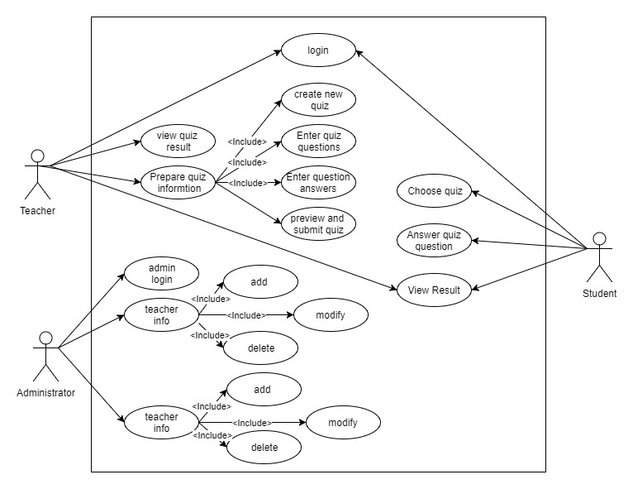

**4.2 Class Diagram**

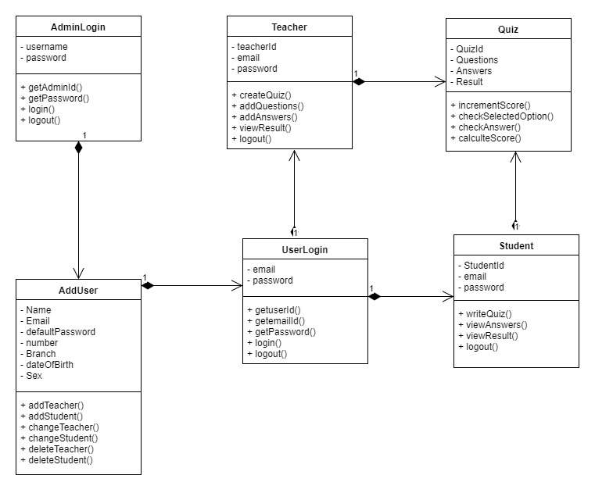

**4.2 Sequence Diagram**

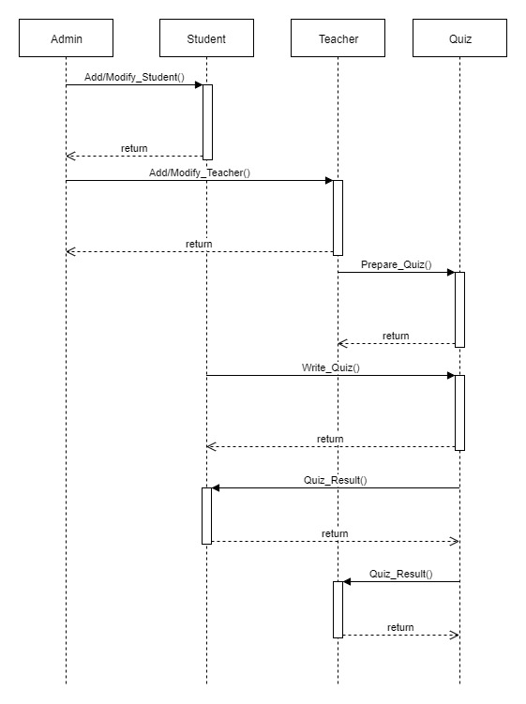

**4.3 Activity Diagram**

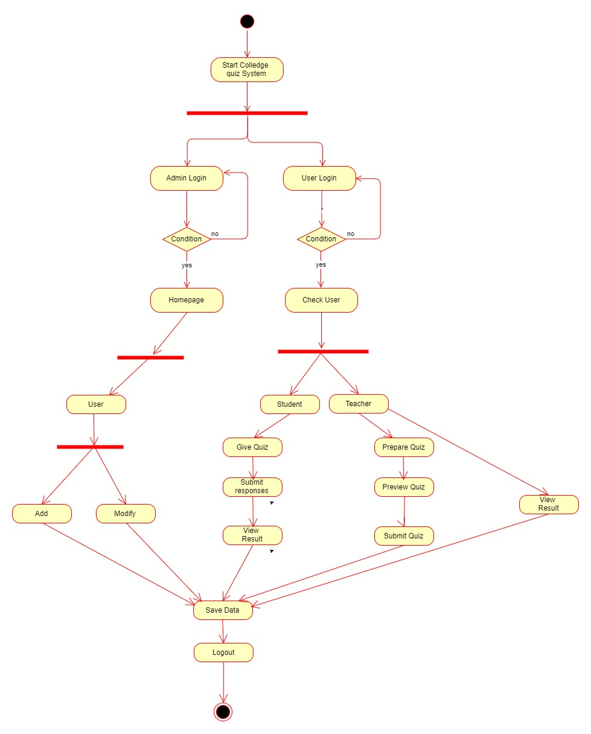

**4.4 Deployment Diagram**

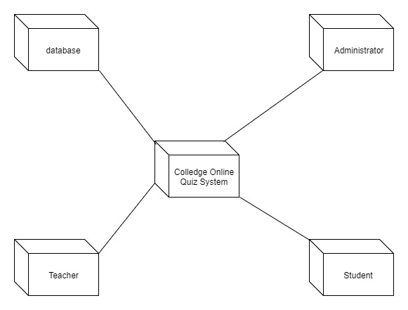

**4.5 Component Diagram**

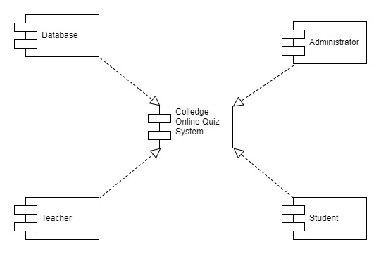

**[5] GUI Screenshots**

**5.1 User Login**

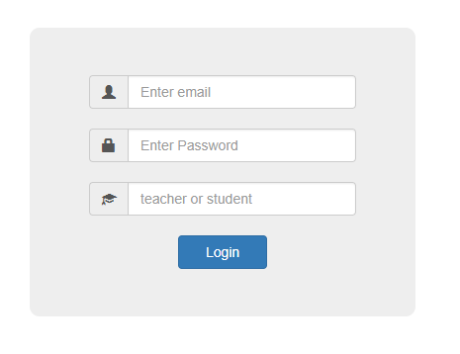

**5.2 Admin Home Page**

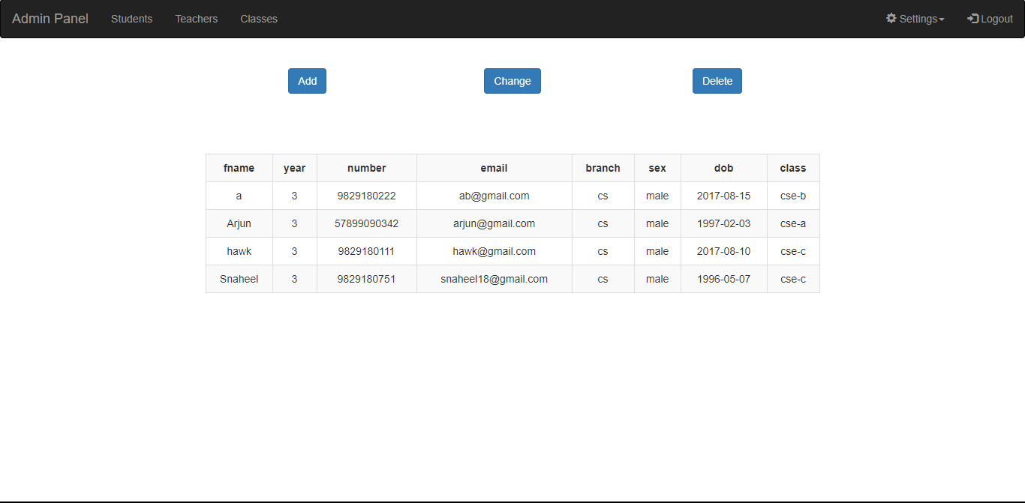

**5.3 Teacher Quiz Preparation**

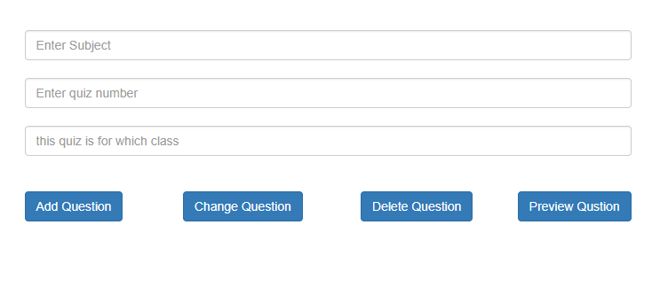

**5.4 Student Homepage**

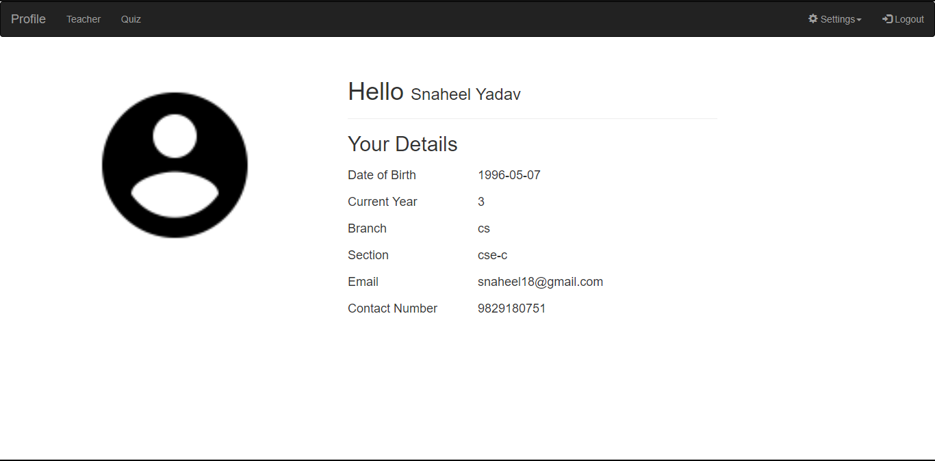

**5.5 Online Quiz**



